Chapter 13, Solution 17.

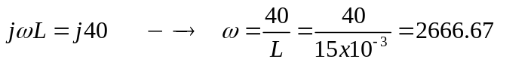
2667 rad/s

11.384 mH

If 15 mH 40 Ω

Then 12 mH 32 Ω
30 mH 80 Ω
11.384 mH 30.36 Ω

The circuit becomes that shown below.

22 Ω
60 Ω
j32 Ω
j80 Ω
•
•
j30.36 Ω

Z_{L}=j40Ω

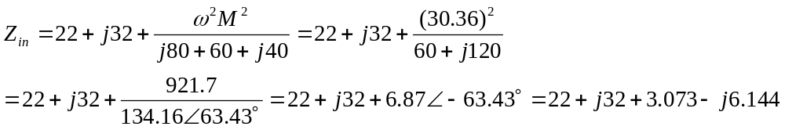

= [25.07 + j25.86] Ω.

